**Task-2:**

* TABLE – SALES PERSON

CREATE TABLE sales_person(s_no int(20) PRIMARY KEY AUTO_INCREMENT , s_name varchar(250) NOT null , city varchar(250) NOT null , comm varchar(250))

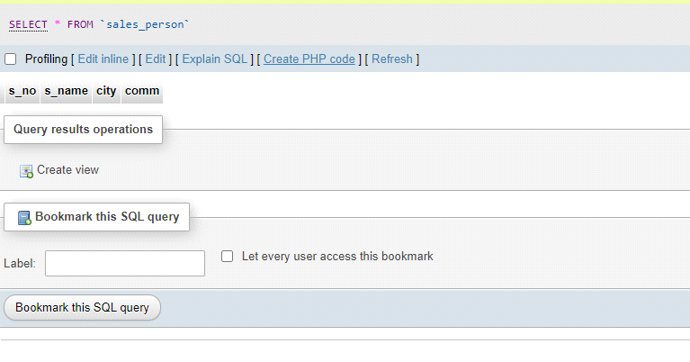

* TABLE CUSTOMER

CREATE TABLE customer(cnm int(20) PRIMARY KEY AUTO_INCREMENT , cname varchar(250) NOT null , city varchar(250) not null ,

rating int(50) NOT null, sno int(20) not null , FOREIGN KEY (sno) REFERENCES sales_person(sno));

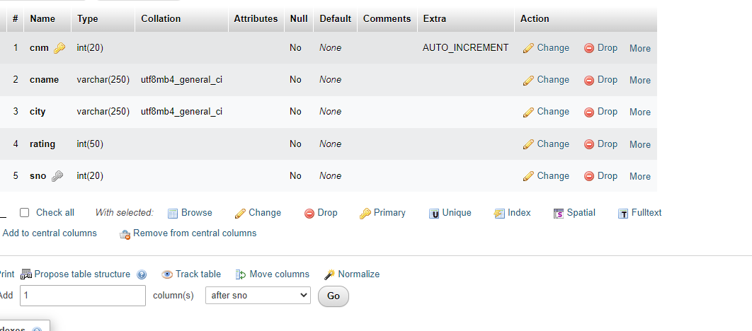

* CREATE TABLE ORDER

CREATE TABLE orders(onm int(20) PRIMARY KEY AUTO_INCREMENT , amt int(50) not null , ode date not null , cnm int(20) not null , sno int(20) not null ,FOREIGN KEY (cnm) REFERENCES customer(cnm) , FOREIGN key (sno) REFERENCES sales_person(sno));

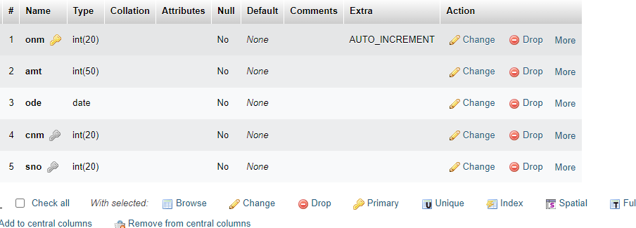

* INSERT SALES_PERSON

INSERT INTO sales_person(s_no,s_name,city,comm) VALUES ('1001','PEEL','LONDON','0.12')

INSERT INTO sales_person(s_no,s_name,city,comm) VALUES ('1002','SERRES','SAN JOSE','0.13')

INSERT INTO sales_person(s_no,s_name,city,comm) VALUES ('10003','AXELROD','NEW YORK','0.1')

INSERT INTO sales_person(s_no,s_name,city,comm) VALUE('10004','MOTIKA','LONDON','0.11')

INSERT INTO sales_person(s_no,s_name,city,comm) VALUES ('10007','RAFKIN','BARCELONA','0.15')

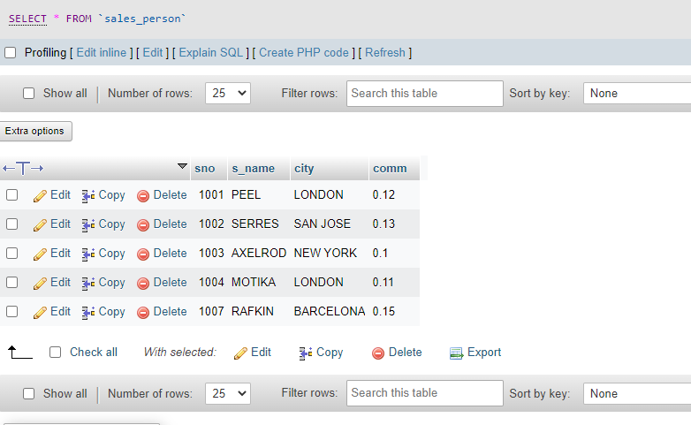

* INSERT CUSTOMER

[INSERT](http://localhost/phpmyadmin/url.php?url=https://dev.mysql.com/doc/refman/8.0/en/insert.html) INTO customer(cnm,cname,city,rating,sno) VALUE('201','HOFFMAN','LONDON','100','1001');

INSERT INTO customer(cnm,cname,city,rating,sno) VALUE('202','GIOVANNE','ROME','200','1003');

INSERT INTO customer(cnm,cname,city,rating,sno) VALUE('203','LIU','SAN JOSE','300','1002');

[INSERT](http://localhost/phpmyadmin/url.php?url=https://dev.mysql.com/doc/refman/8.0/en/insert.html) INTO customer(cnm,cname,city,rating,sno) VALUE('204','GRASS','BARCELONA','100','1002');

INSERT INTO customer(cnm,cname,city,rating,sno) VALUE('206','CLEMENS','LONDON','300','1007');

INSERT INTO customer(cnm,cname,city,rating,sno) VALUE('207','PEREIRA','ROME','100','1004');

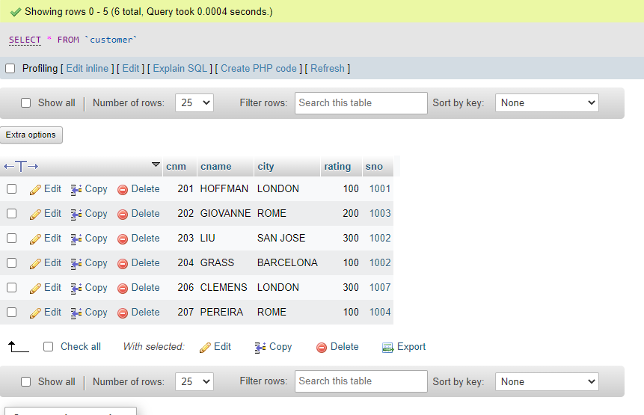

* INSERT ORDERS

CREATE PROCEDURE insert_orders(

IN onm int(20),

IN amt int(50),

IN ode date,

IN cnm int(20),

IN sno int(20))

BEGIN

INSERT INTO insert_orders(onm , amt , ode , cnm , sno)VALUES(onm , amt , ode , cnm , sno);

END//

INSERT ORDERS

INSERT INTO orders(onm,amt,ode,cnm,sno) VALUE('3001','18.69','1994-10-03','201','1007');

INSERT INTO orders(onm,amt,ode,cnm,sno) VALUE('3002','1900.01','1994-10-03','207','1004');

INSERT INTO orders(onm,amt,ode,cnm,sno) VALUE('3003','767.19','1994-10-03','201','1001');

INSERT INTO orders(onm,amt,ode,cnm,sno) VALUE('3005','3005','1994-10-03','203','1002');

INSERT INTO orders(onm,amt,ode,cnm,sno) VALUE('3006','3006','1994-10-04','201','1007');

INSERT INTO orders(onm,amt,ode,cnm,sno) VALUE('3007','3007','1994-10-05','204','1002');

INSERT INTO orders(onm,amt,ode,cnm,sno) VALUE('3008','3008','1994-10-05','206','1001');

INSERT INTO orders(onm,amt,ode,cnm,sno) VALUE('3009','3009','1994-10-04','202','1003');

INSERT INTO orders(onm,amt,ode,cnm,sno) VALUE('3010','3010','1994-10-06','204','1002');

INSERT INTO orders(onm,amt,ode,cnm,sno) VALUE('3011','3011','1994-10-06','206','1001');

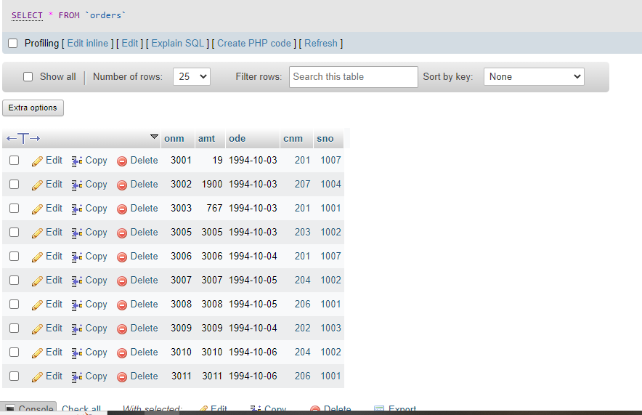

* SQL QUERIES

1. All orders for more than $1000.

[SELECT](http://localhost/phpmyadmin/url.php?url=https://dev.mysql.com/doc/refman/8.0/en/select.html) * FROM orders WHERE amt >1000;

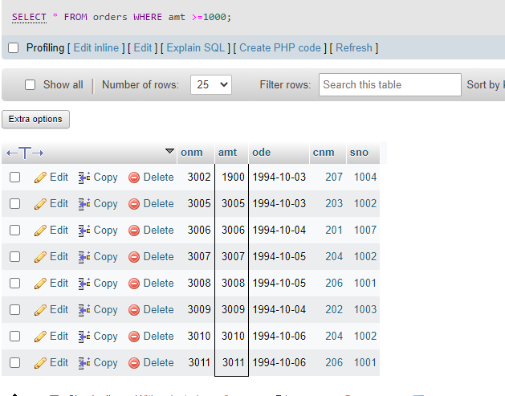

1. Names and cities of all salespeople in London with commission above 0.10.

[SELECT](http://localhost/phpmyadmin/url.php?url=https://dev.mysql.com/doc/refman/8.0/en/select.html) s_name, city FROM sales_person

 WHERE comm > 0.10 [and](http://localhost/phpmyadmin/url.php?url=https://dev.mysql.com/doc/refman/8.0/en/logical-operators.html%23operator_and) city = 'London';

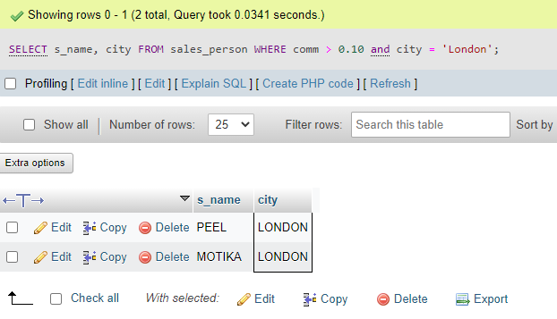

1. All salespeople either in Barcelona or in London.

[SELECT](http://localhost/phpmyadmin/url.php?url=https://dev.mysql.com/doc/refman/8.0/en/select.html) * FROM customer WHERE city [IN](http://localhost/phpmyadmin/url.php?url=https://dev.mysql.com/doc/refman/8.0/en/comparison-operators.html%23function_in) ('Barcelona', 'London');

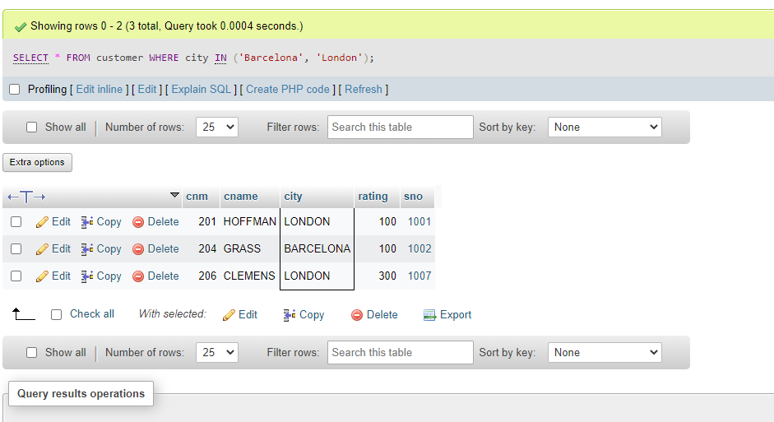

1. All salespeople with commission between 0.10 and 0.12. (Boundary values should be excluded).
2. Select s_name,comm from sales_person where comm > 0.10 and comm < 0.12;

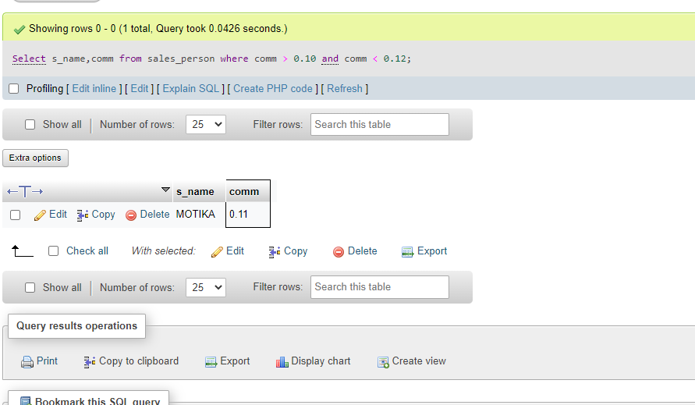

e) All customers with NULL values in city column.

[Select](http://localhost/phpmyadmin/url.php?url=https://dev.mysql.com/doc/refman/8.0/en/select.html) cnm from customer where city [is](http://localhost/phpmyadmin/url.php?url=https://dev.mysql.com/doc/refman/8.0/en/comparison-operators.html%23operator_is) null;

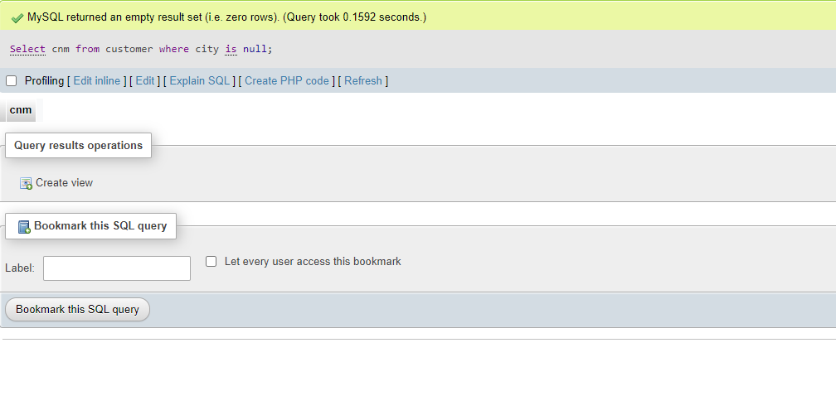

f)All orders taken on Oct 3Rd and Oct 4th 1994.

[SELECT](http://localhost/phpmyadmin/url.php?url=https://dev.mysql.com/doc/refman/8.0/en/select.html) * FROM orders WHERE ode [IN](http://localhost/phpmyadmin/url.php?url=https://dev.mysql.com/doc/refman/8.0/en/comparison-operators.html%23function_in) ('1994-10-03', '1994-10-04');

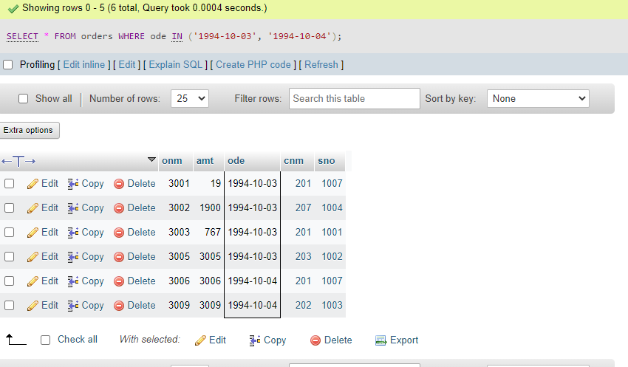

g)All customers serviced by peel or Motika.

h) All customers whose names begin with a letter from A to B

[select](http://localhost/phpmyadmin/url.php?url=https://dev.mysql.com/doc/refman/8.0/en/select.html) cnm from customer where cnm [like](http://localhost/phpmyadmin/url.php?url=https://dev.mysql.com/doc/refman/8.0/en/string-comparison-functions.html%23operator_like) '%a' [AND](http://localhost/phpmyadmin/url.php?url=https://dev.mysql.com/doc/refman/8.0/en/logical-operators.html%23operator_and) cnm [like](http://localhost/phpmyadmin/url.php?url=https://dev.mysql.com/doc/refman/8.0/en/string-comparison-functions.html%23operator_like) '%b';

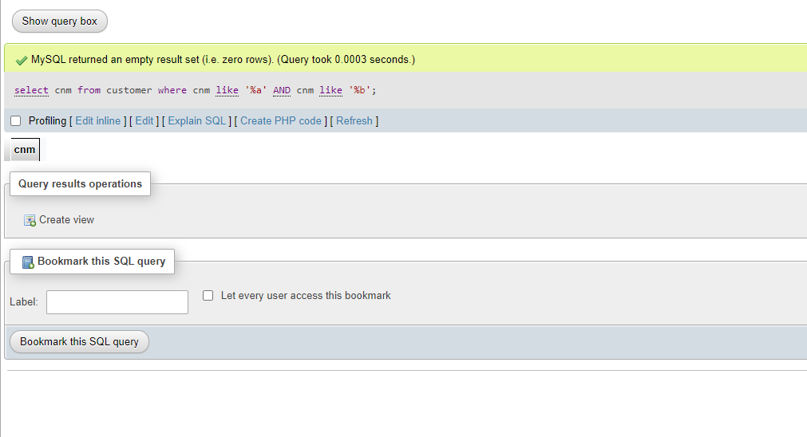i)All customers excluding those with rating <= 100 unless they are located in Rome.

j) All orders except those with 0 or NULL value in amt field.

[Select](http://localhost/phpmyadmin/url.php?url=https://dev.mysql.com/doc/refman/8.0/en/select.html) onm from orders where amt != 0 [or](http://localhost/phpmyadmin/url.php?url=https://dev.mysql.com/doc/refman/8.0/en/logical-operators.html%23operator_or) amt [is](http://localhost/phpmyadmin/url.php?url=https://dev.mysql.com/doc/refman/8.0/en/comparison-operators.html%23operator_is) [not](http://localhost/phpmyadmin/url.php?url=https://dev.mysql.com/doc/refman/8.0/en/logical-operators.html%23operator_not) null;

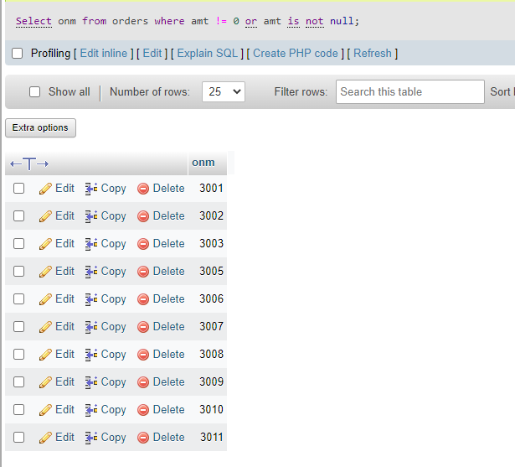

K) Count the number of salespeople currently listing orders in the order table.

[Select](http://localhost/phpmyadmin/url.php?url=https://dev.mysql.com/doc/refman/8.0/en/select.html) [count](http://localhost/phpmyadmin/url.php?url=https://dev.mysql.com/doc/refman/8.0/en/aggregate-functions.html%23function_count)(distinct sno) from orders;

